

**Placement Empowerment Program**

***Cloud Computing and DevOps Centre***

____________________________________________

# POC 4: Create a Simple Backup Script

## Create a script that backs up your entire Git repository to a local folder daily

____________________________________________

Name: Jeslin Anista J

Department: EEE



# Introduction

By creation a local git repository, each developer gets their own local repository, complete with a full history of commits. Having a full local history makes Git fast, since it means you don't need a network connection to create commits, inspect previous versions of a file, or perform diffs between commits

____________________________________________

# Step-by-Step Overview

## **Step 1**

Check if your system has git installed else Download git your sytem

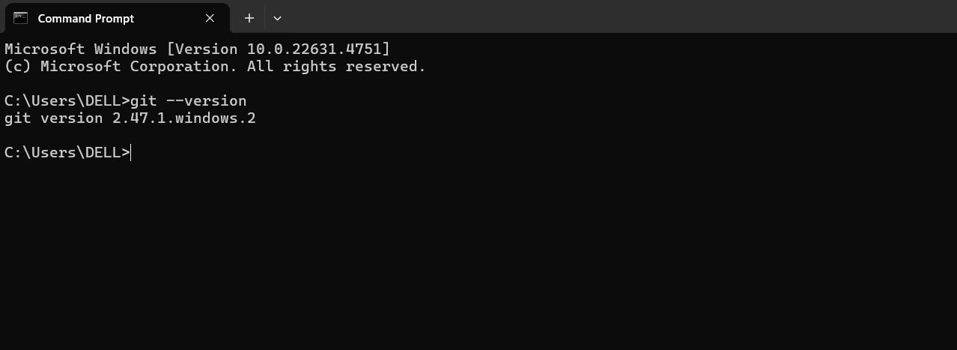

## **Step 2**

Open notepad and type the following code

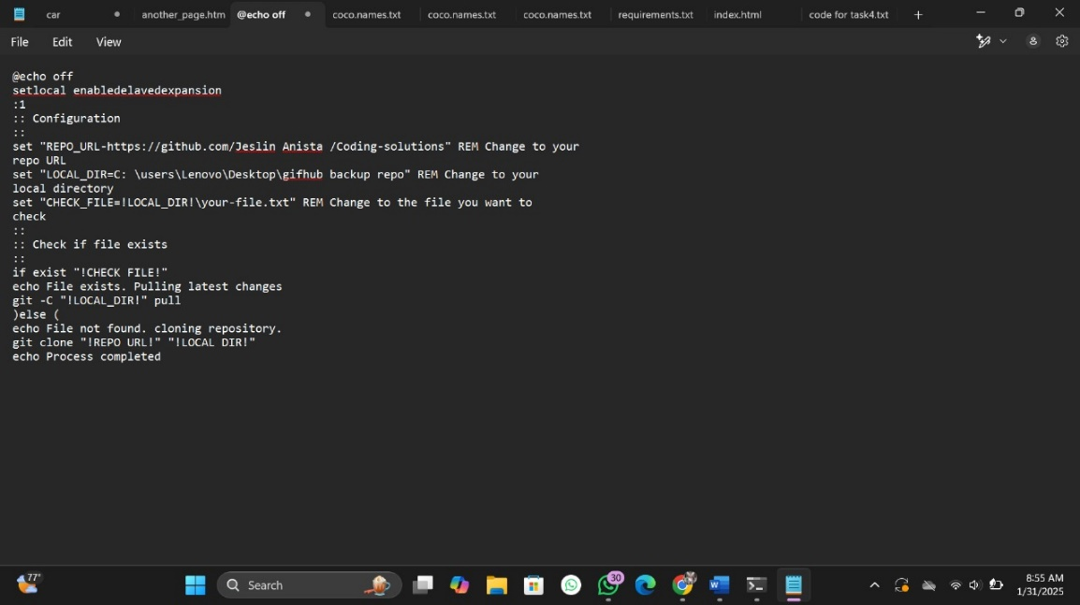

## **Step 3**

Save it with “.bat” extension

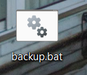

## **Step 4**

Create a folder for backup

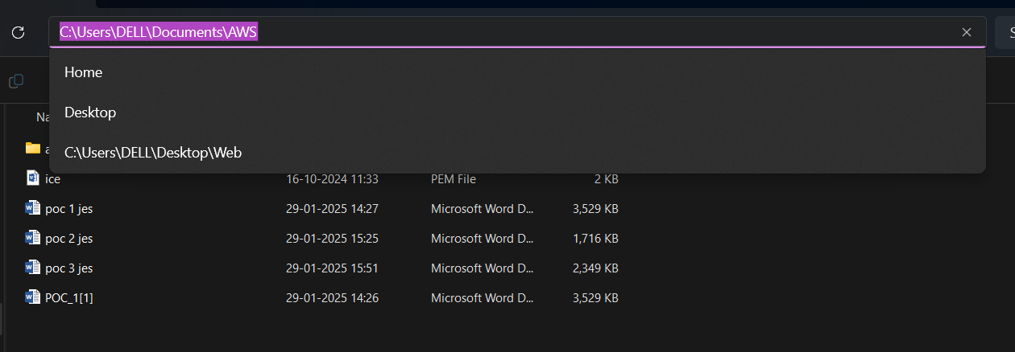

## **Step 5**

Open task manager, create a new basic task and a wizard will guide the setup .enter name ,description and time ,then enter the code in the “.bat”extension file by clicking in “browse”.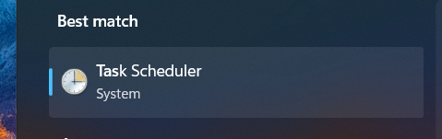

## **Step 6**

An automatic backup system has been created

# Outcome

A local repository is a copy of the entire project's history and codebase that resides on a developer's machine. When a developer initializes a local repository, Git sets up the necessary infrastructure to track changes, branches, and commits within the project .We can create a local repository by the following commands